












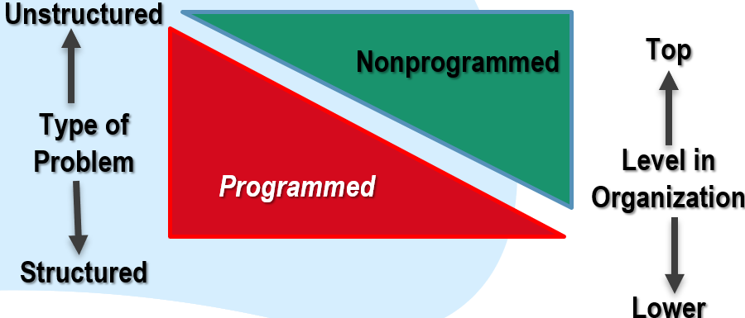
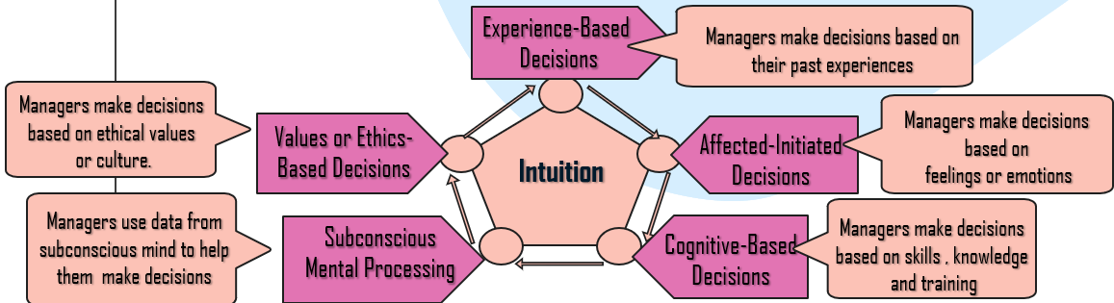
What is Decision Making : Decision Making is a process, not a simple act of choosing among alternatives.
When Are Groups Most Effective?
Meaning
What is Problem: A discrepancy between an existing and a desired state of affairs.
What is Implementing the Decision: Putting a decision into action.
What is Identifying Decision Criteria : Relevant Factors: Price , Model , Size , Manufacturer , Options , and Repair record.
types
Hindsight
Selective
Perception
Anchoring Effect
Immediate
Gratification
Confirmation
Overconfidence
Availability
Randomness
Representation
Overconfidence
Framing
Revision
Self-serving
Sunk Costs
Risk
Certainty
Uncertainty
PLANNING
Defining goals by establishing
strategies and make action
plans to coordinate
activities.
LEADING
Directing and motivating
all parties involved, also
sorting out conflicts
ORGANIZING
Decide what need to be
done, how will it be done
and who will do it
CONTROLLING
Monitoring activities to
ensure they achieved as
Planned.
Rational decision making is choices that are consistent and value-maximizing within specified constraints.
Satisfice is accepting soluting that are “good enough”.
Bounded Rationality is making decisions that are rational within the limits of a manager’s ability to
process information.
Structured problem
Unstructured problem
A situation in which a decision
maker is able to estimate the
likelihood of certain outcomes
A situation in which a decision
maker can make accurate decision because all outcomes are known.
A situation in which a decision
Maker has neither certainty nor reasonable probability estimates available.
The decision maker can have clear picture of the problems, straightforward, familiar, easily defined and to completed it .
They are new or unusual problems for which information is ambiguous or incomplete.
Programmed
Nonprogrammed
A repetitive decisions that can be handled using
a routine approach.
A unique and nonrecurring decision that requires a custom made solution.
Group decision-making is a situation faced when individuals collectively make a choice from the alternatives before them.
The decision is then no longer attributable to any single individual who is a member of the group.
Decisions are often made by groups representing the people who will be most affected by those decisions.
Committees
Task forces
Review panels
Work teams
1.Advantages of Group Decision Makin
2.Disadvantages of Group Decision Making
Diversity of experiences/perspectives
More complete information
More alternatives generated
Increased acceptance of solution
Increased legitimacy
Time-consuming
Minority domination
Ambiguous responsibility
Pressures to conform
Individual
-Faster decision making
-More efficient use of work hours

Group
-More accurate decisions
-More creative
-More heterogeneous representation
-Greater acceptance of final solution
When a group exerts extensive pressure on an individual to withhold his or her different views in order to appear to be in agreement.
What it does
Hinders decision making, possibly jeopardizing the quality of the decision by:
- Undermining critical thinking in the group .
- Affecting a group’s ability to objectively appraise alternatives.
Deterring individuals from critically appraising unusual , minority, or unpopular views.
How to minimize it
Encourage cohesiveness.
Foster open discussion
Have an impartial leader who seeks input from all members.
How it occurs
Group members rationalize resistance to assumptions.
Members directly pressure those who express doubts or question the majority’s views and arguments.
Members who have doubts or differing points of view avoid deviating from what appears to be group consensus.
An illusion of unanimity prevails.Full agreement is assumed if no one speaks up.
Brainstorming:An idea – generating process that encourages alternatives while withholding criticism.
The nominal group technique
:A decision making technique in which group members are physically present but operate independently
Electronic
meetings:A type of nominal group technique in which participants are linked by computer
National culture:
influences the way decisions are made and the degree of risk involved.
Design thinking: approaching management problems as
designers approach design
problems.
Creativity lets the decision maker:Understand a problem more fully See problems others can’t Identify all viable alternatives
Big Data: the vast amounts
Of quantifiable information
that can be analyzed by highly sophisticated data processing
THE DECISION–MAKING PROCESS
Decision-Making Errors and Biases
Decision-Making Conditions
Management functions
What Is Intuition?
Types of Decisions
The Tragedy of Groupthink
Problems Differ/ Type of Problems
Problems, Decision Types, and Organizational Levels
Group Decision Making
Improving Group Decision Making
Contemporary Issues in Managerial Decision Making.
Chapter 1 The Managerial Decision Making

