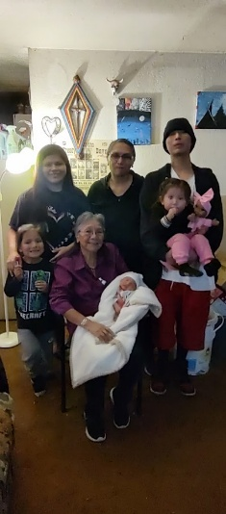
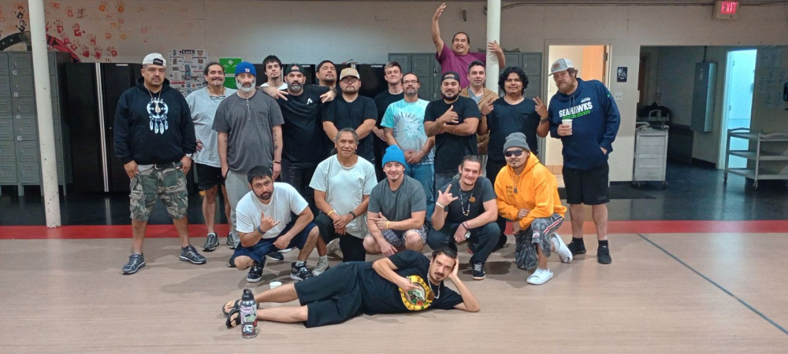
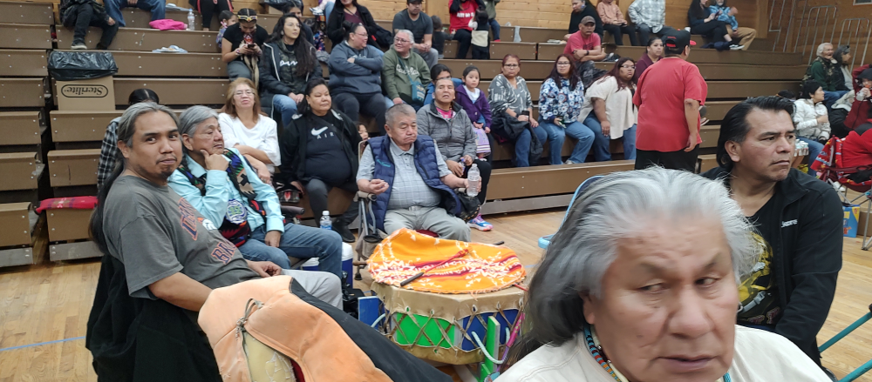
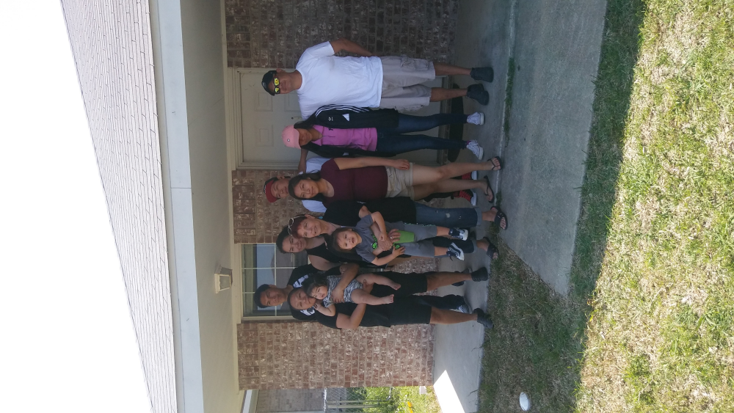
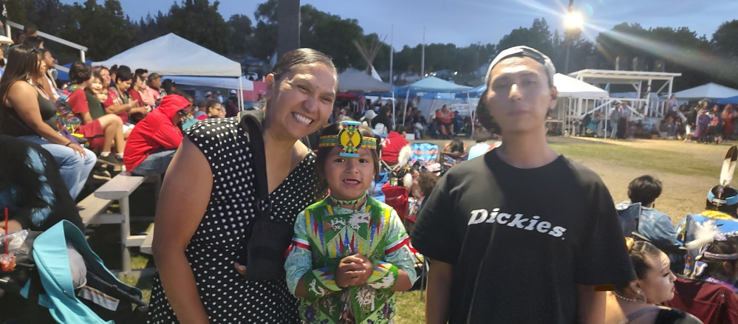
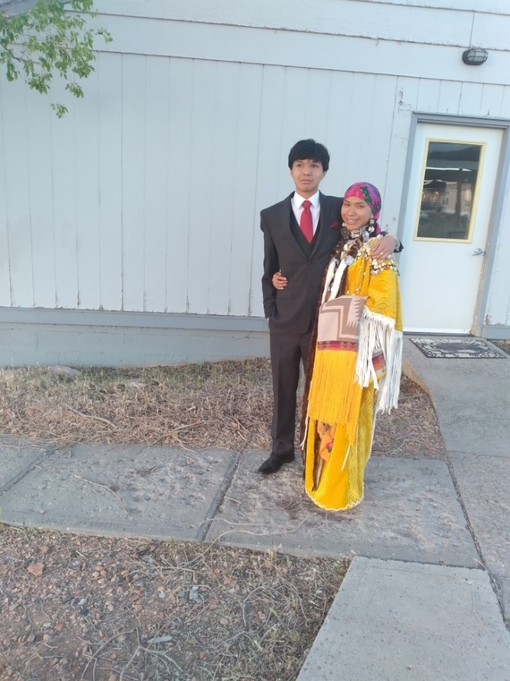
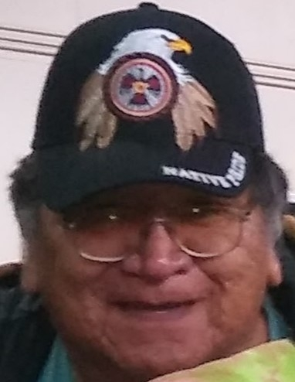
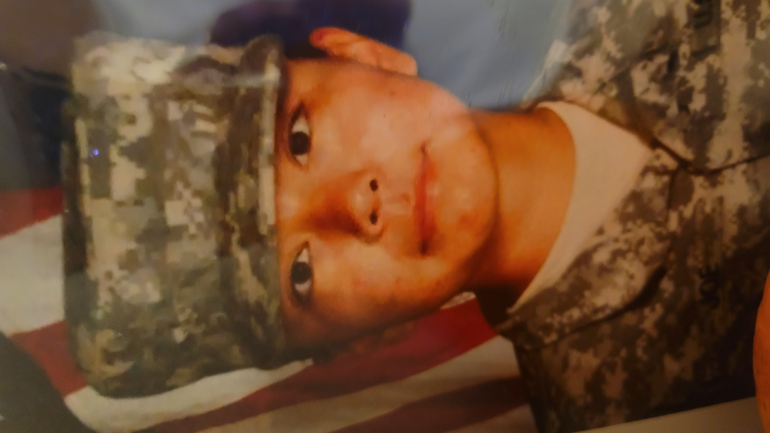
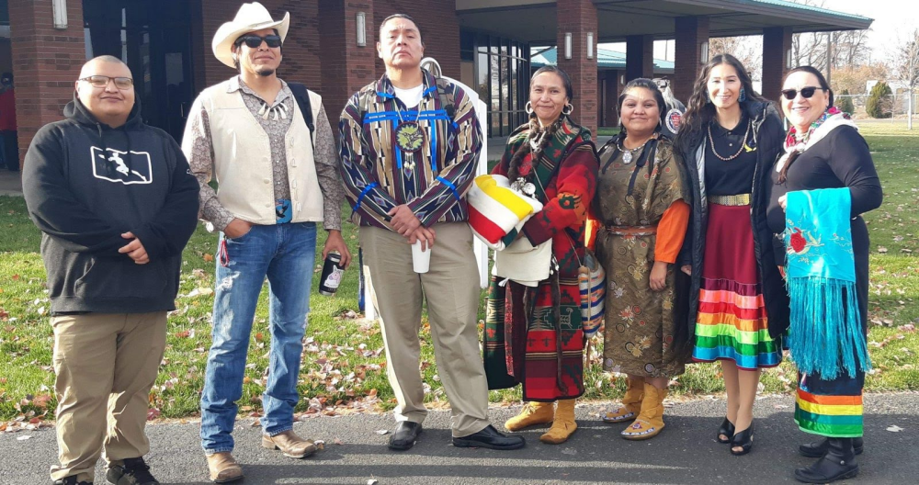
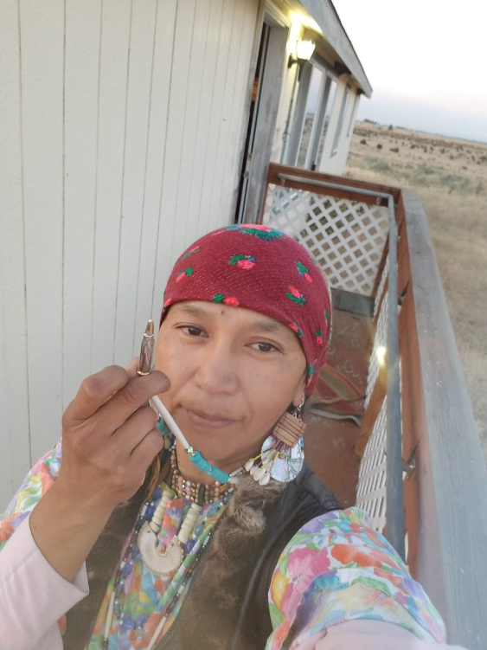
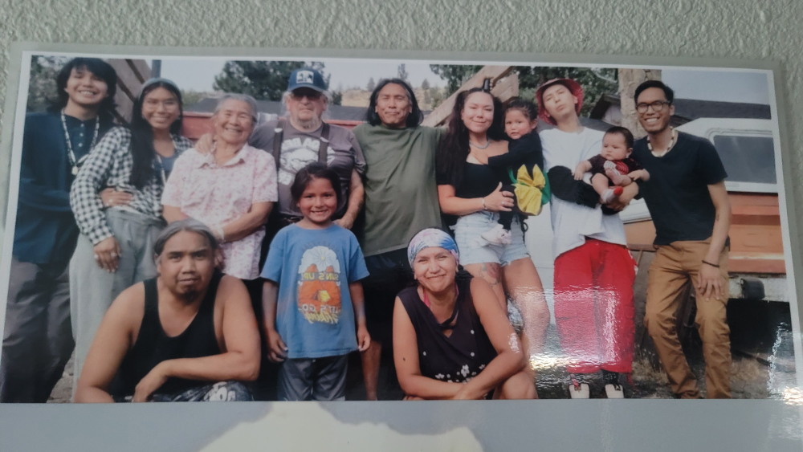
49
Atwai Steven Archie Joe
54
30
27
23
20
Ecological Context
Family Life Cycle
Migration/Acculturation
Family Organization
CULTURAL DIVERSITY
(values,beliefs)
SOCIAL JUSTICE
discrimination racism
Phoebe
La qai ̲ͯ i ya wa shaik sh nai
Dorothea
Buddy
Levi
Clarissa
Shap taw ała
K´ pash wai s´amtuuk pama
C´yaat
Ya ͯ͟ ti
Numut
Melinda
74
Step-father
Married 1975/Divorced 1984
Robert Jasond Luey
2/22/47-01/27/22
43
Kakanis Michael AaronBuck

Step-father
Lester Poitra
02/02/1950
74
74
- 2nd generation
- Warm Springs Oregon/Navajo-Diné Reservation/Yakama Reservation
- Employed/FT student
- WS Elementary School/Heritage University
- Washat/Wampt/Shaker Church/Nazarene
- Contextual dangers (drugs, alcohol, violence)
- Contextual protection (language, social network)
- Ethnic allegiance, community
- IHS/Traditional healing

- Culture Resistance
- Alternate
- Biculturalism
- Cultural bifocality
- Hybridization
- Family loyalty & autonomy
- Suicide attempts (mother 1984/youngest daughter2024, youngest son2022)
- Absences of crucial life-cycle-markers
- WWII from Rock Creek WA to WSO
- Frozen grief
- Transnationalism
- Intergenerational conflicts
- Family under-involved caused by separation and reunifications
- Divorced (2008)
- Children with father (2008)
- Cultural gap
- Reverse culture shock
- Education increased each generation
- Psychological or virtual family: those who stayed or went to Umatilla OR
- Nuclear
- Other people in the household
- Lived with grandmother both sides of parents
- Long distance connections
- Strong bond with mother and children
- Intergenerational bond
- Relational stresses:
Oppression
Descrimination
Exploitation of marginalized people
Bullying
Group exclusion
Prejudice
Hate crimes
Racial trauma

Distant
Male
Atwai - passed on
Female
Strong bond
Key
Married 1991-present

